**Breeding Bird Monitoring Protocol for the Heartland Inventory and Monitoring Network**

**Standard Operation Procedure 5: Documenting Habitat Variables**

**Version 3.00 (04/08/2020)**

**Revision History Log:**

|  |  |  |  |  |  |
| --- | --- | --- | --- | --- | --- |
| Previous Version # | Revision Date | Author | Changes Made | Reason for Change | New Version # |
| 1.00 | May 2008 | D.G. Peitz | Entire document | Edited to reflect changes in horizontal profile measures and subplots sampled. Edited to reflect that bird monitoring has been expanded to ten additional network parks | 2.00 |
| 2.00 | May 2018 | D.G. Peitz | Updated throughout to NRR format. | Made SOP NRSS compliant. | 3.00 |
| 2.00 | April 2020 | D.G. Peitz | Edited text clarifying habitat sampling techniques. | Edited text to clarify habitat sampling techniques. Standardized verbiage with that used in the vegetation community monitoring protocol for consistency and to aid in cross-training field help for both projects. | 3.0 |
|  |  |  |  |  |  |

This Standard Operating Procedure gives step-by-step instructions for measuring bird habitat composition and structure at park units within the Heartland Inventory and Monitoring Network. This Standard Operating Procedure describes the procedure for establishing the 50.0-m habitat plot, and 1.78- and 5-m sampling subplots. This Standard Operating Procedure also describes the procedure for collecting data and filling in the “Field Data Form - Bird Habitat Monitoring Data Sheet” (Form 2).

**Procedure**

1. The sequence in which plots are sampled for habitat measurements follows the order plots are selected for Variable Circular Plot bird counts that day. To avoid biasing bird counts, habitat sampling should begin on a plot after the bird surveyor has completed the count and moved to the next plot or take place after bird surveys have ceased for the day. Changing habitat conditions due to plant growth and/or grazing require habitat sampling to be completed by June 30.
2. Sampling will start as soon as the first bird plot for that day has been completed. Observers should stay back from the plot until the count is complete to avoid disturbing the birds. Two-way radios work well to communicate when a plot is ready for habitat sampling. It takes 10-30 minutes to complete habitat sampling for each Variable Circular Plot point. A minimum of two people is required for the habitat work, with the birder joining them after that day’s survey is done.
3. Habitat measurements are taken for a large (50-m radius) plot centered on the bird survey point, as well as subplots within each plot (Figure 5.1).

1.78-m radius subplot

5.0-m radius subplot

Plot

Center

50-m radius plot

**Figure 5.1.** Layout of a 50.0-m radius bird habitat plot and associated 5.0 - and 1.78-m habitat sampling subplots.

1. A surveyor’s pin with two ropes attached is used to delineate two circular subplots with radii of 1.78-m (10 m2) and 5.0-m (78.5 m2). The pin is placed at plot center and the ropes and additional surveyor pins are used to delineate the boundary of the subplots. (Figure 5.1). Ground cover and vegetation foliar cover are recorded within the smaller sample subplot (10 m2); tree density and vegetation profile are measured on the larger sample subplot (78.5 m2).
2. Navigate to the coordinates of the next plot on the list using the GNSS unit (if available) or a compass. The bird surveyor will have marked all completed plots with 36-in pin flags for easy visibility by the habitat crew. The pin flag will be picked up once habitat measures are taken on a plot.
3. Use a new copy of the “Bird Habitat Monitoring Data Sheet” (Form 2) for each habitat plot. Record the following information on each habitat data sheet:

Park Code: A four letter alpha code unique to a particular park (i.e. “ARPO” for Arkansas Post National Memorial, Arkansas; “TAPR” for Tallgrass Prairie National Preserve, Kansas; etc.)

Date: The month (mm) / day (dd) / year (yyyy) data is collected.

Observer Initials: The initials of the first, middle, and last name of each person on the field crew collecting data.

Management Unit: Pasture name or park sub-unit where the variable circular plot is found (i.e. Windmill, Gashouse, etc.); this can be left blank for parks without named sub-units.

Plot: The permanent identification number assigned to a variable circular plot.

Riparian Corridor: Circle “Yes” or “No” depending on whether or not the plot being sampled is one specifically located in a riparian stratum.

***50-m Radius Plot Attributes***

Slope: Slope of the ground across the entire 50-m radius plot is measured using an English clinometer. For slope measurements, use two poles of equal length (1 m) to sight between, and read slope directly off the left-hand scale (degrees slope) of the clinometer (Figure 5.2). The poles should be positioned at a distance great enough to capture the average slope of the land across the 50-m radius plot. Slope is measured in degrees the first time a plot is measured and is not recorded in subsequent years.

Var: Circle an option of high, medium or low to describe the up and down variability in the slope across the entire 50-m radius plot.

Sight line

1-m



Slope

Clinometer

1-m

**Figure 5.2.** A diagram of measuring slope using a clinometer and sighting poles.

Aspect: The slope direction of the 50-m radius plot. Compass readings will be taken with the declination set at 0°. Aspect is recorded from 0° to 359°, with 360° recorded as 0°. Aspect is measured when the plot is established and is not recorded in subsequent years.

Var: Circle an option of high, medium or low to describe the variability in the direction of the slope across the entire 50-m radius plot.

Topographic Position: Circle the most descriptive word for the location of the 50-m radius plot relative to its local position on the earth’s surface. Topographic position is determined when the plot is established and is not recorded in subsequent years.

* + - Level – level top of a plateau or valley floor or shoreline representing the former position of an alluvial plain, lake or shore.
    - Lower-slope – inner gently inclined surface at the base of a slope, generally concave in surface profile. This includes toe slope, the outermost gently inclined surface at the base of a slope, commonly gentle and linear in surface profile.
    - Mid-slope – (transportational mid-slope) – intermediate slope position.
    - Upper-slope (shoulder slope) – the uppermost inclined surface at the top of a slope, typically convex in profile.
    - Escarpment/face – sloping or vertical side of a stream bank or former stream bank.
    - Ledge (terrace, step in slope) – nearly level shelf interrupting a steep slope or cliff face.
    - Crest (interfluve, summit, ridge) – linear top of a ridge, hill or mountain; the elevated area between two drainageways that sheds water to the drainageway.
    - Depression – bowl shaped or similarly depressed area.
    - Draw – depressed V-shaped drainage that carries water toward a stream.

Vegetation Type: An ocular estimate of the percent coverage of habitat types (Table 5.1.) on the 50-m radius plot. Cover is estimated within modified Daubenmire (1959) cover classes, following standard Heartland Inventory and Monitoring Network procedures (Table 5.2).

**Table 5.1.** Habitat types on 50-m radius plots (includes non-vegetation railroad track habitat type).

|  |  |  |
| --- | --- | --- |
| **Habitat type** | **Habitat type** | **Habitat type** |
| Brome Field | Lawn | Shrub |
| Corn Field | Old Field | Soybean Field |
| Disturbed Floodplain | Open Woodland | Trail |
| Disturbed Prairie | Parking Lot | Tree Line |
| Drainage | Railroad Tracks | Upland prairie |
| Fescue/Orchard Grass | Restored Prairie | Western Wheatgrass |
| Field/Prairie | Riparian Prairie | Wetland |
| Floodplain | Riparian Woodland | Woodland |
| Highway Right of Way | River Terraces | Woodland Swamp |
| Intermittent Water Cover | Seep | Other |

**Table 5.2.** Cover is estimated within modified Daubenmire (1959) cover classes.

|  |  |
| --- | --- |
| **Cover class** | **Cover (%)** |
| 0 | none present |
| 1 | trace - 1.0 |
| 2 | * 1. - 5 |
| 3 | 5.1 - 25 |
| 4 | 25.1 - 50 |
| 5 | 50.1 - 75 |
| 6 | 75.1 - 95 |
| 7 | 95.1 - 100 |

Road Cover**:** An ocular estimate of the percent of ground covered by pasture or paved roadway on the 50-m radius plot. Estimates of cover will be in standard Heartland Inventory and Monitoring Network cover classes for both paved and pasture roads (Table 5.2).

Water Cover**:** An ocular estimate of the percent of ground covered by pond or stream on the 50-m radius plot. Estimates of cover will be in standard Heartland Inventory and Monitoring Network cover classes for both streams and ponds (Table 5.2).

Plot Notes**:** This space is provided to record comments on the 50-m radius plot.

***5-m Radius Subplot Attributes***

Slope:Slope of the ground across the subplot is measured using an English clinometer. Slope is measured in degrees with a clinometer the first time a subplot is measured and is not recorded in subsequent years. For slope measurements, use two poles of equal length (1 m) to sight between and read slope directly off the left-hand scale (slope) of the clinometer (Figure 5.2). The poles should be positioned at a distance great enough to capture the average slope of the land across the subplot. Subplot slope is measured when the plot is established and is not recorded in subsequent years.

Aspect: The slope direction of the subplot. Compass readings will be taken with the declination set at 0o. Aspect is recorded from 0 o to 359 o, with 360 o recorded as 0 o. Subplot aspect is measured when the plot is established and is not recorded in subsequent years.

Tree Tally:Tree species are identified to genus (species if possible) and recorded using a code consisting of the first five letters of the individual’s genus name (six letter genus species code if the tree is identified to species). Counts are taken on all tree species > 1.5 m tall within the 5.0-m radius subplot. Use a dot tally method to count (Table 5.3) by genus (species if possible) and size class based on diameter at breast height (i.e. 1.37 m above ground).

* less than 1.0 cm in diameter
* l.1-2.5 cm diameter
* 2.6-8.0 cm diameter
* 8.1-15.0 cm diameter
* 15.1-23.0 cm diameter
* 23.1-38.0 cm diameter
* greater than 38.0 cm diameter

**Table 5.3.** Dot tallies are recorded as follows and repeated for the next count of ten trees and so on.

|  |  |  |  |  |
| --- | --- | --- | --- | --- |
| One tree | Two trees | Three trees | Four trees | Five trees |
| • | • • | • •  • | • •  • • | • •  • • |
| Six trees | Seven trees | Eight trees | Nine Trees | Ten trees |
| • •  • • | • •  • • | • •  • • | • •  • • | • •  • • |

Canopy Height:Canopy heights of the tallest hardwood and coniferous trees influencing a 5-m radius subplot are measured to a 1/4 meter with a metric clinometer equipped with 15-m and 20-m scales (Figure 5.3). The tree(s) measured do not have to be within the plot radius, they only need to influence vegetation within the plot. When measured from a distance of 15 m or 20 m, tree heights can be read directly from the instrument’s scales. The readings should be doubled when measuring from distances of 30 m or 40 m. The actual measurement of a tree’s height is done by an observer sighting the top of the tree with both eyes open and reading the numeric value on the scale (right scale for 15 m and left scale for 20 m distance) where the hair line crosses. This gives a height of a tree (canopy) from eye level. The observer then measures from eye level to the base of the tree at ground level. Canopy height is the height of the tree +/- the height of the tree from eye level to the ground. If the base of the tree is above eye level, the value read is positive and will need to be subtracted from the height of the tree measured from the top of the tree at eye level. If the base of the tree is below eye level, the value read is negative and it will need to be added to the height of the tree measured from the top of the tree at eye level. Total canopy height is the height of the tallest tree recorded, hardwood or coniferous.

15 or 20 meters

Eye level

clinometer

Measurement 1

Measurement 2

**Figure 5.3.** Using a clinometer to measure tree height. Tree height is taken at a distance of 15 (right scale) or 20 m (left scale) depending on the height of the tree. Trees greater than 20 m should be measured at a distance of 30 (right scale) or 40 m (left scale) and the clinometer reading doubled. Measurement 1 should be added to measurement 2 if it is a negative number and subtracted if it is positive to obtain tree height.

Canopy Cover:Densiometers are used at each 10-m2 plot (Figure 5.4) to observe amount of canopy cover. The spherical densiometer consists of a concave mirror with 24, ¼ inch squares engraved on the surface. Densiometer measurements are collected after the ground flora measurements are completed to avoid trampling the plot prior to reading it. The observer stands over the plot center and collects four densitometer readings one facing each of the four cardinal directions (N, E, S, W). Hold the densiometer level, 12” to 18” in front of body at breast height, so the operator’s head is not reflected in the grid area. The 24 squares on the densiometer are divided into 96 imaginary dots, assuming equally spaced dots in each square of the grid (Figure 5.4A). Record the number of dots out of 96 that are covered by canopy (green leaves). If canopy openings are counted rather than canopy cover, subtract from 96 to obtain canopy coverage. The number of dots covered by canopy will be converted to percent canopy closure (multiplied by 1.04) during the data summary process (not in the field). Canopy closure will be read separately for hardwood canopy, conifer canopy, and total canopy.

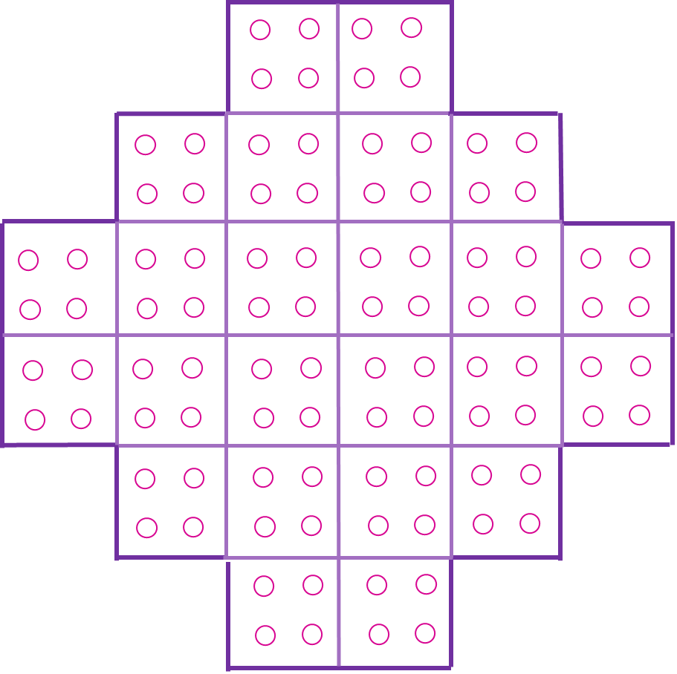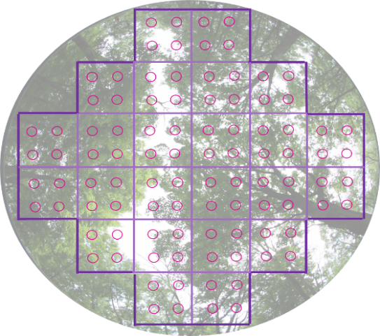

**B**

**A**

**Figure 5.4.** A) Illustration of the grid on the concave mirror of the densiometer. B) Illustration of a view of the canopy superimposed on a densitometer grid. Record 85 for the observation for image B.

Basal Area**:** Basal area of hardwood and conifer species is estimated using a 10-factor English cruz-all (Figure 5.5). Holding the button at the end of the chain in the teeth (or against the chin), extend the cruz-all angle gauge away from the eye until the chain is taut. Keeping the eye directly over the subplot center, look through the cruz-all at every tree. Count trees that appear as wide or wider, at breast height, than the opening for the basal area factor being used (10). Tree counts will be converted to basal area estimates (m2/ha) during the data summary process by multiplying counts by 2.5. Count hardwood and conifer species separately. Total basal area is the combined basal area of hardwood and conifers.

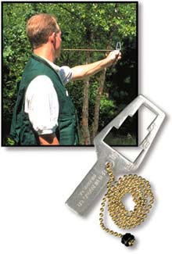

5

20

10

Tree stem

**Figure 5.5.** Using a cruz-all to count trees for basal area estimates. Count trees with the 10-factor opening on the cruz-all.

Horizontal Vegetation Profile: Vegetation profile readings are taken by an observer located at a distance of 15 m perpendicular to the profile board. The profile board is located at plot center and the reader is located 15 m away at an azimuth of 0o (compass declination is set at 0o). The observer utilizes a sighting pole marked at 0.5, 1.0, and 1.5 m above the ground to adjust their eye position as they read the board from bottom to top (Figure 5.6). Profile board strata 0-0.25 and 0.25-0.50 should be read with the observer’s eye at the designated distance above the ground for each stratum (Figure 5.6). Observers should sight with one eye to prevent parallax problems. The area of the profile board obscured by vegetation, both live and standing dead, between the board and observer is measured using a modified Daubenmire (1959) cover class value (Table 5.2) for each of the strata marked on the board.

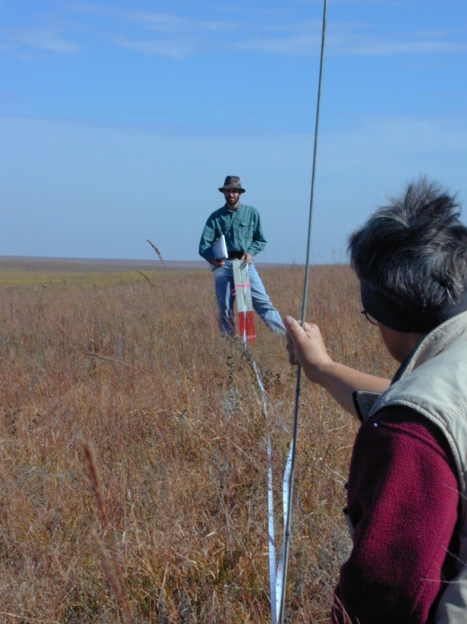

Observer height intervals:

Stratum Observer height

0.00-0.25 0.5

0.25-0.50 0.5

0.50-0.75 1.0

0.75-1.00 1.0

1.00-1.25 1.0

1.25-1.50 1.5

1.50-1.75 1.5

1.75-2.00 1.5

**Figure 5.6.** Conducting the horizontal cover measurements using profile board and sighting pole.

Vertical Profile of Vegetation:Vertical vegetation profile is measured using a 7.5-m rod marked in meter intervals. Touches or ‘hits’ of vegetation against the rod are recorded in each interval for deciduous (D), herbaceous (H) and/or coniferous (C) vegetation. Measurements are taken on the periphery of a 5-m radius subplot in the four cardinal directions (N, E, S, W) from plot center; therefore, the maximum number of ‘hits’ per increment for each vegetation type is four. See Figure 5.7 for an example of how to measure the vertical profile of vegetation.

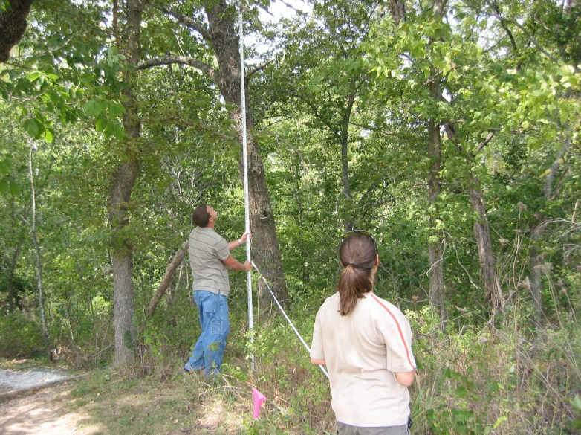

7 - 7.5 m

0 – 1 m

1 – 2 m

2 – 3 m

3 – 4 m

4 – 5 m

5 – 6 m

6 – 7 m

**Figure 5.7.** Conducting the vertical profile measurements using a 7.5-m measuring rod. As shown in the figure to the right, a conifer touches the measuring rod between 0 - 1, 1 - 2, 2 -3 and 3 - 4 m increments. Herbaceous vegetation touches the measuring rod between 0 - 1 m.

***1.78-m Radius Subplot Attributes***

Ground Cover:An ocular estimate of ground cover is made within a 10-m2 (1.78-m radius) sampling plot centered on each subplot. Cover of the ground surface is estimated within modified Daubenmire (1959) cover classes (Table 5.2). Percent ground cover is estimated for the following parameters:

* Deciduous Leaf Litter: deciduous tree and woody shrub leaf litter.
* Conifer Litter: conifer leaf litter and organic debris.
* Grass Litter: cover of dead grass and grass-like plants (leaf and stem material) no longer standing – should be distinguishable as grass/grass like plant.
* Bare Soil: soil surface not covered by litter, plant, or rock.
* Bare Rock: rocks > 2.54 cm.
* Woody Debris: area covered by dead and down woody material regardless of size (twigs, logs, etc.) in contact with the ground.
* Unvegetated: 100 minus the total percent basal cover of living plants. Ground cover categories can be >100% because litter types can overlap.

Foliar Cover: An ocular estimate of aerial foliar cover is made within a 10-m2 (1.78-m radius) sampling plot centered on each subplot. The estimate is a vertical projection of foliar cover from plants less than 1.5 m in height onto the ground surface. Cover is estimated within modified Daubenmire (1959) cover classes (Table 5.2). If a vegetation category is not present in the plot, enter a 0 for that parameter – do not leave empty records. Percent foliar cover is estimated for the following plant guilds:

* Warm-season grasses — includes warm season grasses.
* Cool-season grasses — includes graminoid species (e.g. sedges).
* Forbs — includes yucca, cactus, ferns and other herbaceous vascular plants.
* Moss and lichen— mosses and lichens.
* Woody shrubs and vines — woody shrubs and vines rooted in the plot.
* Tree Regeneration — includes seedlings less than 1.5 m in height.
* Total Foliar Cover — vertical projection of total foliar cover of living vegetation (less than 1.5 m in height) onto the ground surface.

**Literature Cited**

Daubenmire, R.F. 1959. Canopy coverage method of vegetation analysis. Northwest Science 33:43-64.

Field Data Form - Bird Habitat Monitoring Data Sheet (Form 2)

**Park Code: ________ Date:** (mm/dd/yyyy) _________ **Observer(s) Initials:** ______________________

**Management Unit: ___________ Plot: __________ Riparian Corridor:** Yes No

**PLOT ATTRIBUTES:** (50-m radius)

**Slope (o):** ________ **Var:** high med low **Aspect (o):** _______ **Var:** high med low

**Topographic position:**

level lower-slope mid-slope upper-slope escarpment/face ledge crest depression draw

|  |  |  |  |  |  |
| --- | --- | --- | --- | --- | --- |
| **Vegetation Type:** | **Cover Class:** | **Vegetation Type:** | **Cover Class:** | **Road Cover:** | **Cover Class:** |
|  |  |  |  | Paved |  |
|  |  |  |  | Pasture |  |
|  |  |  |  | **Water Cover:** |  |
|  |  |  |  | Stream |  |
|  |  |  |  | Pond |  |

**Plot Notes: __________________________________________________________________________________**

**SUBPLOT: ______ Random Azimuth (o):** _______ **Slope(o):** _______ **Aspect (o): _______**

**TREE TALLY** (by dbh size class)

|  |  |  |  |  |  |  |  |
| --- | --- | --- | --- | --- | --- | --- | --- |
| **Species** | **<1.0 cm** | **1.1 – 2.5 cm** | **2.6 – 8.0 cm** | **8.1 – 15.0 cm** | **15.1 – 23.0 cm** | **23.1 – 38.0 cm** | **>38.0 cm** |
|  |  |  |  |  |  |  |  |
|  |  |  |  |  |  |  |  |
|  |  |  |  |  |  |  |  |
|  |  |  |  |  |  |  |  |
|  |  |  |  |  |  |  |  |

**CANOPY HEIGHT**: (m) **CANOPY COVER**: (dots covered out of 96) **BASAL AREA**:

Hardwood: _____ Hardwood: 1___ 2 ___ 3 ___ 4 ___ Hardwood: _____

Conifer: _____ Conifer: 1___ 2 ___ 3 ___ 4 ___ Conifer: _____

Total: 1___ 2 ___ 3 ___ 4 ___

|  |  |  |  |
| --- | --- | --- | --- |
| **GROUND COVER:** | **Cover Class:** | **FOLIAR COVER** (by guilds)**:** | **Cover Class:** |
| Deciduous Leaf Litter |  | Warm Season Grass |  |
| Conifer Leaf Litter |  | Cool Season Grass |  |
| Grass Litter |  | Forbs |  |
| Bare Soil |  | Moss and Lichen |  |
| Rock |  | Shrubs & Vines |  |
| Woody Debris |  | Tree Regeneration |  |
| Unvegetated |  | Total Foliar Cover (< 1.5 m tall) |  |

**HORIZONTAL VEGETATION PROFILE BOARD: (measured at a distance of 15-m true North)**

0.25 m: _____ 0.50 m: _____ 0.75 m: _____ 1.0 m: _____ 1.25 m: _____ 1.5 m: _____ 1.75 m: _____ 2.0 m:_____

**VEGETATION PROFILE (D = Deciduous, H = Herbaceous, C = Conifer)**

|  |  |  |  |  |  |  |  |
| --- | --- | --- | --- | --- | --- | --- | --- |
| 0–1 m | 1–2 m | 2–3 m | 3–4 m | 4–5 m | 5–6 m | 6–7 m | 7–7.5 m |
|  |  |  |  |  |  |  |  |
|  |  |  |  |  |  |  |  |
|  |  |  |  |  |  |  |  |
|  |  |  |  |  |  |  |  |

**Bird Habitat Data Form: Categories, Definitions and Descriptions.**

50-m VEGETATION TYPE (includes non-vegetation habitat types)

|  |  |  |
| --- | --- | --- |
| Brome Field | Lawn | Shrub |
| Corn Field | Old Field | Soybean Field |
| Disturbed Floodplain | Open Woodland | Trail |
| Disturbed Prairie | Parking Lot | Tree Line |
| Drainage | Railroad Tracks | Upland prairie |
| Fescue/Orchard Grass | Restored Prairie | Western Wheatgrass |
| Field/Prairie | Riparian Prairie | Wetland |
| Floodplain | Riparian Woodland | Woodland |
| Highway Right of Way | River Terraces | Woodland Swamp |
| Intermittent Water Cover | Seep | Other |

COVER CLASS DEFINITIONS AND CUTPOINT DESCRIPTIONS

|  |  |  |  |  |
| --- | --- | --- | --- | --- |
| Cover class | Definition | Upper cutpoints for 50-m radius plot | Upper cutpoints for 5-m radius plot | Upper cutpoints for 1.78-m radius plot |
| 0 | None present |  |  |  |
| 1 | Trace to 1 % | A circle of radius 5.00 m | A circle of radius 0.50 m | A circle of radius 0.18 m |
| 2 | 1 – 5 % | A circle of radius 11.18 m | A circle of radius 1.12 m | A circle of radius 0.40 m |
| 3 | 5 – 25 % | A circle of radius 25.00 m | A circle of radius 2.50 m | A circle of radius 0.89 m |
| 4 | 25 – 50 % | A circle of radius 35.36-m | A circle of radius 3.54-m | A circle of radius 1.26-m |
| 5 | 50 – 75 % | A circle of radius 43.30 m | A circle of radius 4.33 m | A circle of radius 1.54 m |
| 6 | 75 – 95 % | A circle of radius 48.73 m | A circle of radius 4.87 m | A circle of radius 1.73 m |
| 7 | 95 – 100 % | Full plot radius | Full plot radius | Full plot radius |

HORIZONTAL VEGETATION PROFILE BOARD INCREMENTS and OBSERVATION HEIGHTS

|  |  |
| --- | --- |
| Stratum | Observer height |
| 0.00-0.25 | 0.5 |
| 0.25-0.50 | 0.5 |
| 0.50-0.75 | 1.0 |
| 0.75-1.00 | 1.0 |
| 1.00-1.25 | 1.0 |
| 1.25-1.50 | 1.5 |
| 1.50-1.75 | 1.5 |
| 1.75-2.00 | 1.5 |